

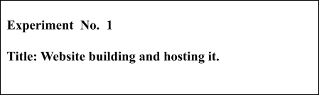

**Batch: B1 Roll No.:16010421119 Experiment No.:1**

**Aim:** Build website and host it.

**--------------------------------------------------------------------------------------------**

**Resources needed:** Web development framework, hosting domain

# Theory:

1. Develop a website having minimum 4 to 5 linked web pages.
2. Host it on any domain.

# Results: (Screenshots of hosting steps and web pages)

website link- <https://aarya-tiwari1211.vercel.app/>



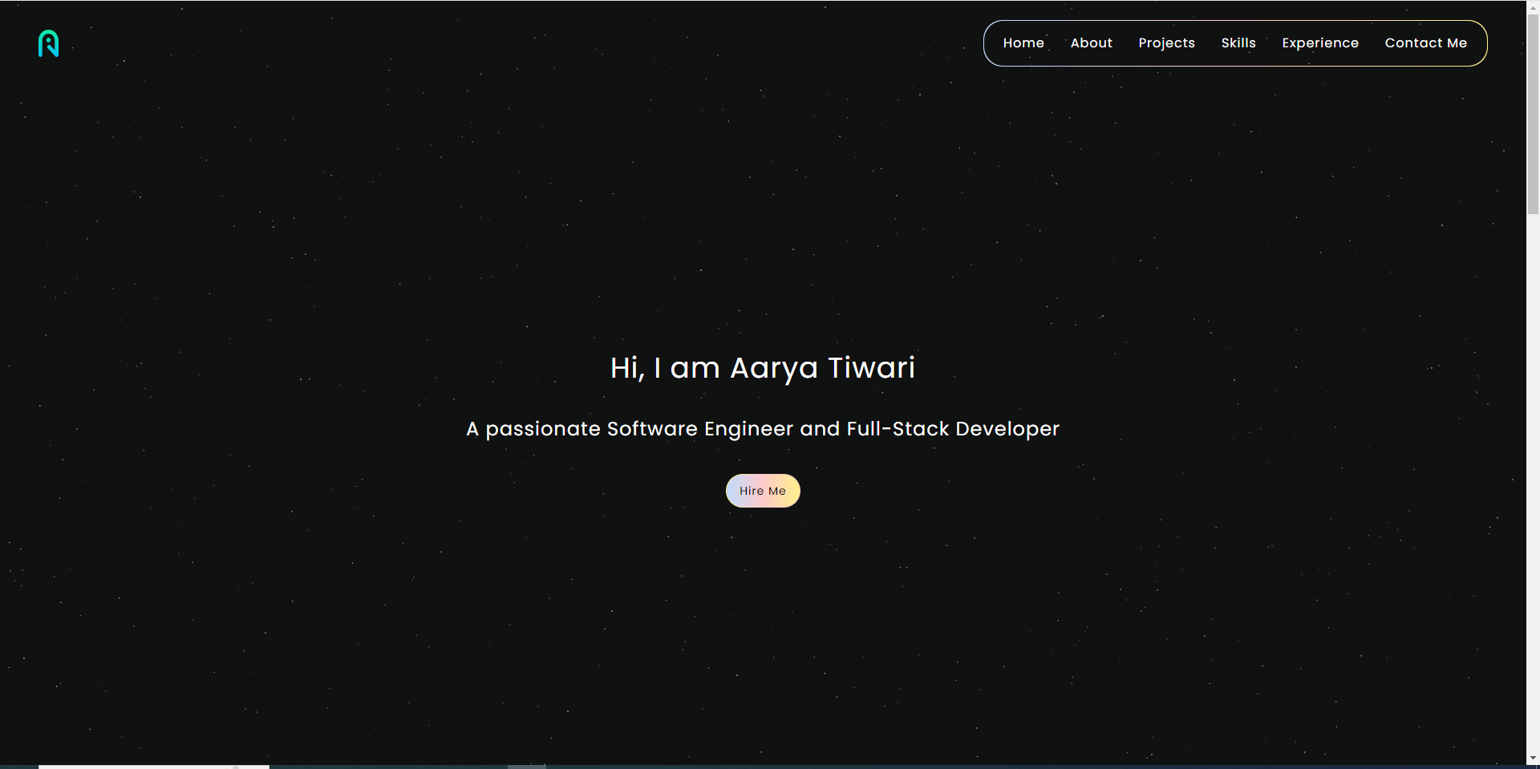

**This webisite is linked to:**

1. **Github**
2. **Linkedn**
3. **Instagram**

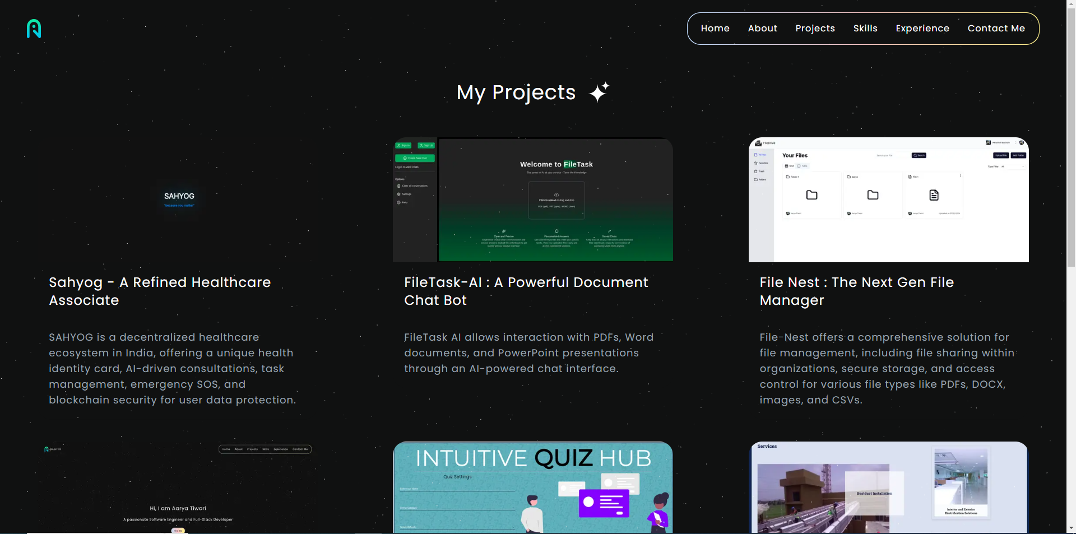

**each project is also linked to its github code base. This website is deployed using Vercel hosting.**



# Questions:

1. Explain any two digital marketing channels.

Digital marketing is the use of websites, apps, mobile devices, social media, search engines, and other digital means to promote and sell products and services.Digital marketing involves many of the same principles as traditional marketing and is often considered an additional way for companies to approach consumers and understand their behavior.

Digital marketing channels, also known as digital advertising channels, are various online platforms and methods businesses use to promote products, services, or brands to consumers. Digital marketing channel examples include websites, social media,

email, SEO, PPC, and content marketing.

* Website Marketing

A website is the online representation of your business or brand. It’s where you showcase your products, services, values, and personality to potential

customers. To attract, engage, and convert your audience. Websites are also great digital marketing channels because they can:

* Build credibility and authority in your niche
* Increase the visibility and reach of your content
* Provide a platform to communicate and interact with your audience
* Collect data and feedback from visitors
* Allow for more versatile marketing campaigns
* Search Engine Optimization (SEO)

Search Engine Optimization, as the name suggests, is about making your website page rank higher on internet search engines like Google, Bing, etc.

Suppose a user does an online search on ‘How to bake a cake.’ If the web page of your recipe is among the top results, the user is more likely to click on it.

Boosting the SEO of your page will not only enhance its online visibility and also improve its traffic and activity. It is an SEO best practice to include relevant keywords and manage links in your content to appear in the unpaid ‘organic’ search lists.

* Social Media Marketing

Social media is one of the most powerful internet marketing channels today. Platforms like Facebook, Instagram, YouTube, Twitter, etc. provide a space for dynamic two-way communication. Internet users spend most of their time in these online spaces. So, brands cannot miss the opportunity to grab more

eyeballs and effectively need to promote their brands.

Users see promoted content based on their profile, interests, likes, and the



content they share. The “everything to everyone” approach no longer works. Moreover, social media makes it possible for organizations to connect with prospects, answer their queries, and enter conversations

* Email Marketing

Email offers a much more personal way of connecting with your targeted

customers. It is a type of internet marketing that can truly make you stand out.

You can offer exclusive ‘insider’ content, special discounts, and customized content to your email subscribers to make them feel special. The attractive bargains may also prompt non-subscribers to sign up for updates.

By implementing the advanced techniques of email marketing, you don’t just help in driving more sales and conversions but also develop a sense of loyalty.

This is one of those online marketing channels that lets you match your

spending to individual clients and know where they stand in their purchasing cycle. However, your well-crafted and targeted email campaign could also end up in the spam folder.

# Outcomes:

CO1: Comprehend change in marketing paradigm from Digital Marketing perspective

**Conclusion: (Conclusion to be based on the objectives and outcomes achieved)** In this experiment, we successfully built a website and successfully deployed it on a hosting platform

# Grade: AA / AB / BB / BC / CC / CD /DD



**Signature of faculty in-charge with date**

# References:

1. Eric Greenberg, Alexander Kates, “Strategic Digital Marketing: Top Digital Experts Share the Formula for Tangible Returns on Your Marketing Investments” McGraw Hill Education 1st edition, 16 August 2013.
2. Jan Zimmerman “Web Marketing For Dummies” Willy Publishing 3rd Edition, 2011.
3. Jan Zimmerman, Deborah Ng, “ Social Media Marketing All-in-One For Dummies” Willy Publishing 4th Edition, 2017.
4. Eric Enge, Stephan Spencer, Jessie Stricchiola, Rand Fishkin, “The Art of SEO”, 2nd Edition Mastering Search Engine Optimization O'Reilly Media 2nd Edition, 2012
5. John I Jerkovic, “SEO Warriors” O'Reilly Media 1st edition, 2009